**Islamabad:**

Faisal Mosque

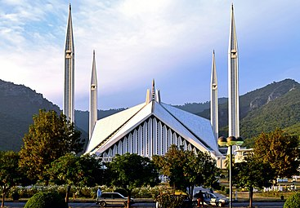

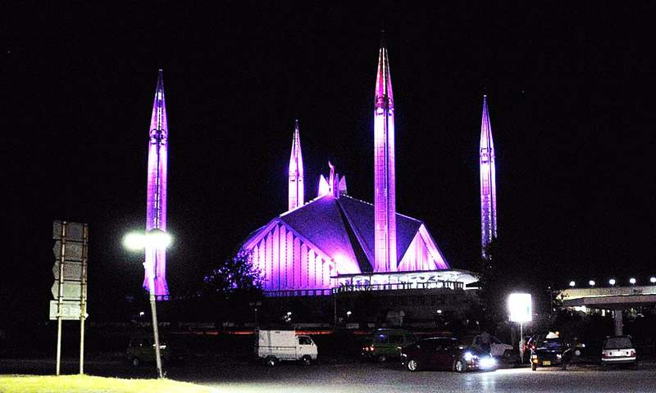

**Faisal Mosque** is a mosque in Islamabad, Pakistan. It is located on the foothills of Margalla Hills in Islamabad, the mosque features a contemporary design consisting of eight sides of concrete shell and is inspired by a Bedouin tent. The mosque is a major tourist attraction, and is referred as a contemporary and influential feature of Islamic architecture.

Daman-e-Koh

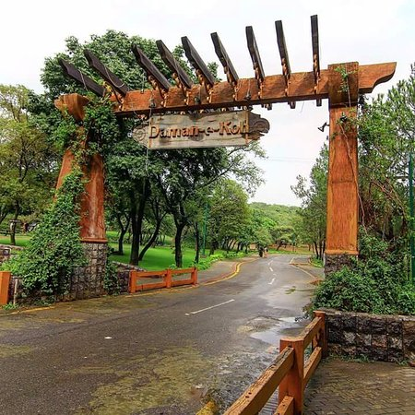

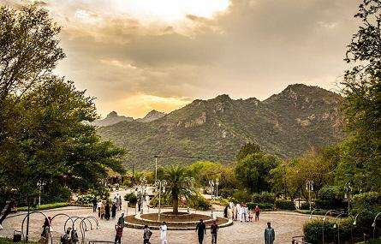

**Daman-e-Koh** is a viewing point and hill top garden north of Islamabad and located in the middle of the Margalla Hills. Its name is a conjunction of two Persian words, which together means foot hills. It is about 2400ft from sea level and almost 500ft from the city of Islamabad. It is a popular destination for the residents as well as the visitors to the capital. Daman-e-Koh is a midpoint for tourists on their way to the higher view point Pir Sohawa which is located at the top of Margalla Hills at an elevation of about 3600ft. There is a plan to construct a chairlift from Daman-e-Koh to Pir Sohawa. Monkeys are a common sight during winter. Cheetahs are frequently reported to descend from higher hills of Murree during snowfall.

Margalla Hills

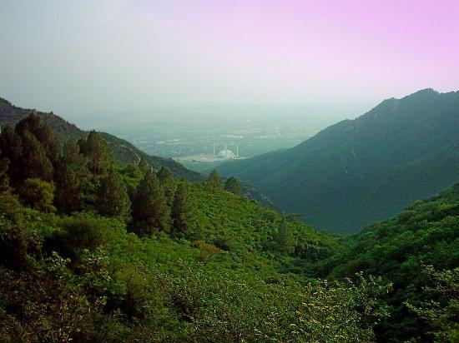

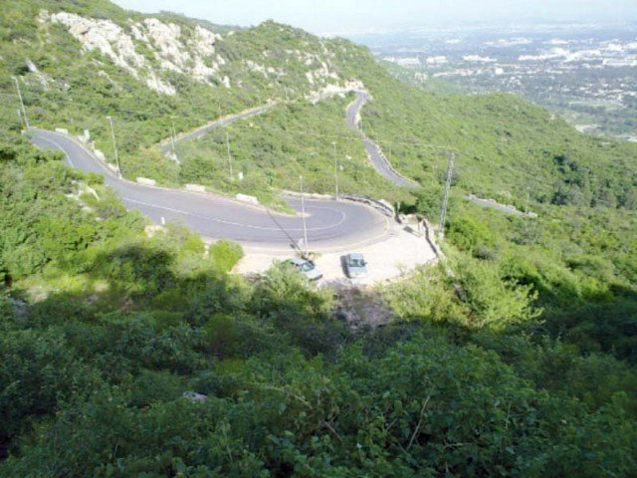

The **Margalla Hills** is a hill range which is part of the Himalayan foothills located within the Margalla Hills National Park, north of Islamabad, Pakistan. The Margalla range has an area of 12,605 hectares. The hills are a part of Murree hills. It is a range with many valleys as well as high mountains.

Rawal Lake

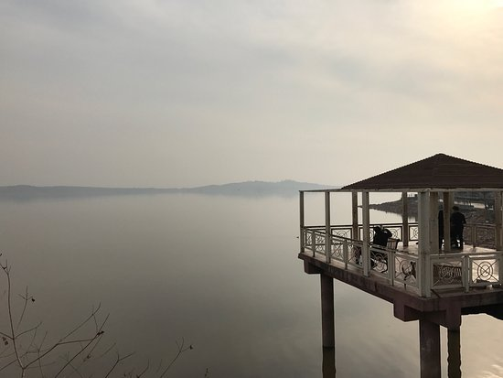

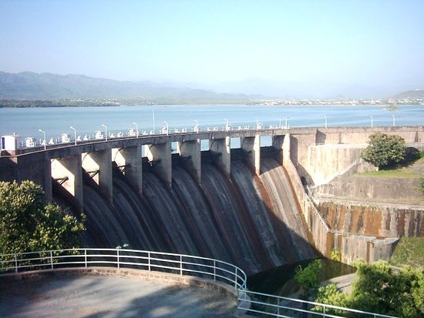

**Rawal Lake** in Pakistan is an artificial reservoir that provides the water needs for the cities of Rawalpindi and Islamabad. Korang River along with some other small streams coming from Margalla Hills have been set to form this artificial lake which covers an area of 8.8km². Korang River is the outlet stream of Rawal Dam. Rawal Lake is located within an isolated section of the Village Malpur, Bani Gala and Margalla Hills National Park. The area around the lake has been planted with flowering trees and laid out with gardens, picnic spots, and secluded paths. The terraced garden and the lake are used for picnics, fishing and boating. The highest point in the garden offers a panoramic view of the lake, Margalla and Murree hills, Rawalpindi and Islamabad.

Taxila Museum

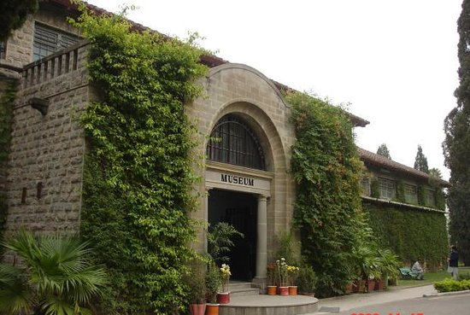

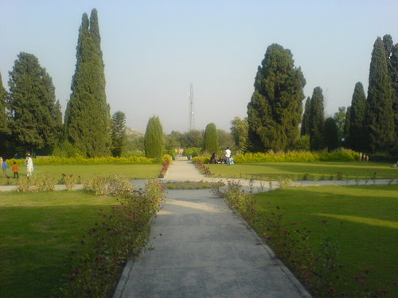

**Taxila Museum** is located at Taxila, Punjab, Pakistan. The museum is home to a significant and comprehensive collection of Gandharan art dating from the 1st to the 7th centuries CE. Most objects in the collection were excavated from the ruins of ancient Taxila.

Pir Sohawa

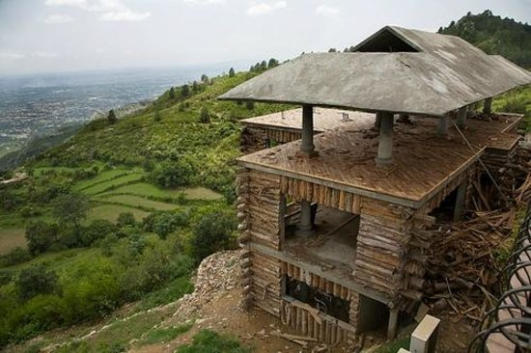

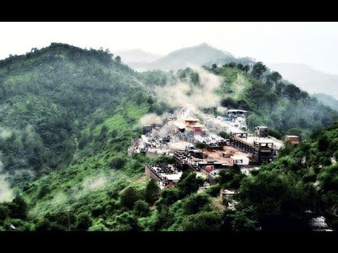

**Pir Sohawa** is a rapidly developing tourist resort located 17 kilometers (11mi) from Islamabad on top of Margalla Hills. It has a 3000 plus ft elevation and located in Monal village which is geographically part of Haripur District. On 6 January 2012, after almost six years, Pir Sohawa, the city’s highest tourist spot, received few inches of snowfall. Bright hills is a holiday resorts at scenic views of canyons on Margalla hills at 4800 feet above sea level. 22 km from zoo islamabad.